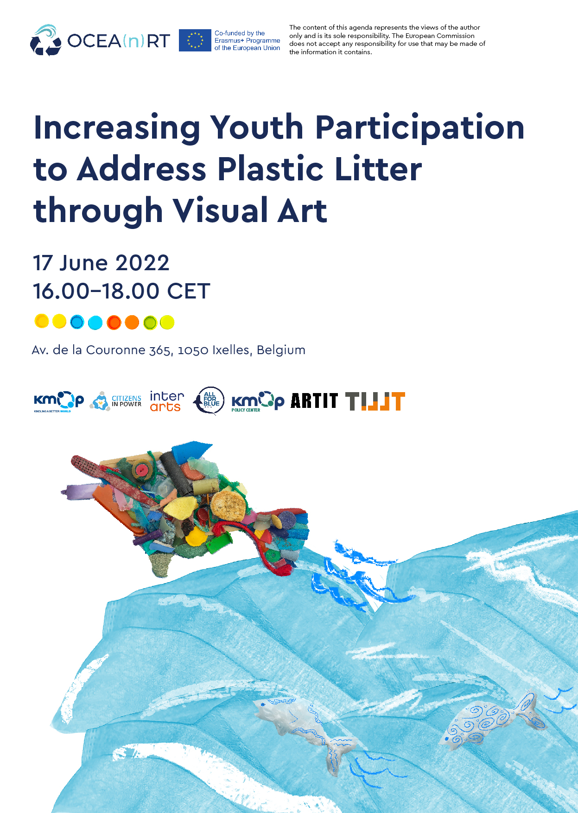

The COVID-19 pandemic has dramatically increased the use of certain types of plastic products, further burdening the environment and more specifically the oceans and the life below water.
On Friday, June 17, 2022, 16.00-18.00 CET, KMOP Policy Center is hosting the online event "Increasing youth participation to address plastic litter through visual art works", organized within the European Erasmus+ project OCEA(n)RT.
The event will give us the opportunity to present the work done during the 2-year project’s lifetime, as well as to boost active youth participation to address plastic – “COVID-Waste” – litter through visual art.
The event is open to the public and will be hosted in English. Certificates of attendance will be provided.

A few words about OCEA(n)RT
“OCEA(n)RT - Boosting youth participation in ocean protection through visual art” is a European project co-funded by the Erasmus+ programme of the European Union. Its goal is to increase the active participation of young people in ocean protection through visual art works. More specifically, the project will strengthen the ability of youth workers to enhance youth participation and to motivate youth to address pandemic relevance to plastic litter through visual art works, and it will enhance access to relevant roadmaps and good practices to ensure youth participation in ocean protection activities. Furthermore, OCEA(n)RT will support CSOs, youth and environmental organisations, cultural and creative sector grassroots to raise public awareness, in order to lead and contribute to the development of youth policies that promote active participation of youth in the fight against marine plastic litter.

ℹ️ For further information, please contact us at: policy-center@kmop.gr.

AGENDA
16.00 - 16.10 | Welcome remarks  Prof. Antonios Klapsis, Moderator
16.10 - 16.40 | Introduction to the OCEA(n)RT project  Vassilios Giannias, Leader of the OCEA(n)RT project, KMOP Policy Center
16.40 - 17.00 | Designing for Sustainability: A Generic Framework  Spyros Bofylatos, Adjunct Lecturer, Department of product and systems design engineering, University of the Aegean
17.00 - 17.30 | The Awareness Raising and Policy Toolkit  Elisa Pajolari, Project Manager, KMOP Policy Center
17.30 - 18.00 | The economic consequences of the plastic pollution  Michael Kefalogiannis, Economist, Chairpeson of the Hellenic Electricity Distribution Network Operator

