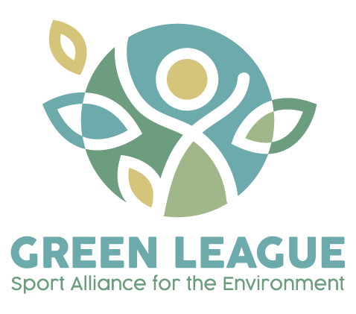
Concepts and methodologies
for
sustainable & green sports’ practices
Green League Model
Acknowledgments

This Manual has been created within the Erasmus+ sport project “Green League – sport Alliance for the Environment” partners: CESIE (coordinator), Italy, Vivi Sano Onlus, Italy, Zavod APGA, Slovenia, Kentro Merimnas Oikogeneias Kai Paidiou (KMOP), Greece, EINURD (Einurd), Iceland, Cardet Centre For The Advancement Of Research & Development In Educational Technology Limited (CARDET), Cyprus, Out of the Box International (OTB), Belgium.

Editor: APGA

Authors:
APGA, Agencija za promocijo gibalnih aktivnosti, Slovenia,
CARDET, Cyprus,
CESIE, Italy,
EINURD, Iceland,
KMOP, Greece,
OTB, Belgium
VIVI SANO ETS, Italy

Edition: electronic

Project reference no.: 101050262
Green League-ERASMUS-SPORT-2021-SCP

Summary

Introduction 5
Foreword 5
About the Project 5
Methodologies 5
Sport and Environment: key issues 6
Ecosystems 6
Potential threats to Ecosystem when performing sport 7

Green League Model 9
Introduction to the Green League Model 9
About the Model 10
Organisation 11
Implementation 13
Promotion 14

Organisation 17

How to structure sport clubs to be green 17
Directives and Policies 17
Stakeholders 19
Organisations 19
Local Community 20
Supporting partners 21
Incentives and benefits 22
International 22
National 22
Local 22

Implementation 23

How to organise green sports activities and events 23
How sports impact the environment 23
Good practices 23
The potential of sport for environmental engagement 24
Sport and sustainable development goals (SDGs) 24
Sport environmental initiatives 24
Planning and Implementation of green sports events 26
Getting started 26
Green recommendations for sports events 27
How to implement sports events in nature combined with environmental reflection 29
How to organise sport events combined with environmental actions 30
Hybrid scoring system 32
Types of Action 33
Awareness Raising activities 33
Events 34
Infrastructure 35
Principles and goals 36
Principles of Green Sport 36
Principles of Green Sport events 36

Promotion 38

How to promote the green sports event to raise awareness 38
Media 38
Communication 39
Education 41
Advocacy 43

Conclusion 45

References 46

Introduction

Foreword
This Manual was created following a collaborative workshop involving 6 sport professionals from 5 European countries. The Green League model contains theoretical and methodological approaches to combine sport activities with environmental education through experiential learning.
In particular the Green League Model includes:
- Guidelines, criteria, and sample activities combining environmental education, experiential learning and sport, and environmentally-sustainable planning and delivery of sport events;
- Lessons learnt from Good Practices on Sport and Environment Protection’ analysis and international collaborative workshop with sport professionals;
- The methodology at the basis of the deployment of sport events inspired by Nature’s Four Elements and of the sport tournaments combined with environmental actions
- The proposal for an innovative hybrid scoring system taking into account both environmental and sport achievements

About the Project
Green League – Sport Alliance for the Environment is a project that aims at enhancing the link between sport and the environment through experiential learning, promoting outdoor physical activity as a tool to support environmental awareness, and encouraging sustainable practices in sport.
It answers the needs of encouraging the population to take urgent action to combat climate change and its impacts and of promoting healthy lives and well-being for everyone, therefore using sport as a tool to generate environmental awareness while contributing to a healthier lifestyle.

Methodologies
The Green League model is based on the connection between sport and the environment. To do this, a series of methodologies must be taken into account, which can be used during the implementation of green sport practices and initiatives.
In particular, the methodologies considered are the following:
- Participatory and collaborative approach
The first step to link the environment with the sport is a participatory and collaborative approach. This means that the sport and the activities should be ideated together with the sport professionals, according to the place where the events will take place, to ensure a higher impact on the local community.
- Experiential learning in and through nature
Organising the Nature's Four Elements sport event in a natural environment gives the possibility to the participants to those events (sport professionals, sport amateurs, young people and their families) to reflect on how sport impacts on the environment while experiencing the environment and it gives also the possibility of shifting sport influence towards increasingly sustainable means. The facilitator, during the sport events in nature, has the role of making the participants reflect on their personal relationship with natural ecosystems, learn about their function, discuss collectively on how they can reduce their environmental impact and on how sport can impact the environment.
- Learning-by-playing approach
The third methodology is learning-by-playing. Through this methodology the participants have the opportunity to learn about environment by playing sport, combining educational activity with a recreational activity, a method that make it fun to learn.
- Sport communities’ endorsement
To have a greater impact, the fourth methodology includes the engagement of both popular athletes and the local communities of players. This ensures that the values and messages behind the project are communicated within the sporting community maximising its impact using videos and photo messages in the form of a ‘call to action’ via their own social media.
- Art and visual storytelling
Creativity and art, as well as visual storytelling is a good methodology to spread key messages, especially through social media. Creating tangible products with materials collected during the sport activities in nature or during sport activities combined with environmental actions, and telling the story of these materials, where they have been found, their negative or positive role for the environment, helps raise the awareness about the environmental issues. The (Green) Zines are important to document the sporting events and widely disseminating (Green League’s) key messages. Participants of the sporting events directly contribute to the content of the zines during the sport activity, the moments of group reflection and exchange of ideas, but also by collecting symbolic materials (feather, litter, etc.) found during their outdoor experience. This helps to raise cooperation and environmental awareness.

Sport and Environment: key issues
This model wants to address some issues regarding the link between sport and environment. Starting from the basic concepts, we analysed the characteristics of ecosystems and the potential threats to them when performing sport, so as to lay down the basis for the development of all the concepts and guidelines included in this model.
Follow an outline of the key basic arguments for better analysing the link between the environment and sport; more information on the following topics can be found in the Sport and Environment Training Package.

Ecosystems
An ecosystem is a geographic area where plants, animals, and other organisms, as well as weather and landscape, work together to form a bubble of life.
It is necessary to consider the characteristics of the different ecosystems to ensure that the delicate balance of each one is not altered or damaged. Although there are many ecosystems on planet earth, this document will focus on the ecosystems that are most suited to the organisation of sports activities: two aquatic ecosystems (fresh and saltwater) and two terrestrial ecosystems (mountain and forest).
Aquatic ecosystems
Aquatic ecosystems are divided into saltwater and freshwater ecosystems. Both are rich in biodiversity and are fundamental to the earth's balance. As we all know, however, these delicate systems are threatened by human activity.
The major threats to aquatic ecosystems are:
- climate change: acidification of the waters that alters the marine balance; ice melting that causes causing extreme events;
- pollution: plastic, microplastic and chemicals that impact marine and coastal fauna and vegetation;
- overfishing: that causes irreparable damage and changes that result in serious losses in biological diversity.
Terrestrial Ecosystems
Of the many terrestrial ecosystems, we consider the mountain and forest ecosystems. Mountain is a complex habitat for living organisms to survive and it is fundamental to life since it acts as a primary source of freshwater.
Forests are among the most valuable and irreplaceable plant associations for the balance of life on Earth. In fact, they serve to protect the soil by keeping it fertile and hindering its desiccation and erosion by atmospheric factors. They help to keep the percentage of atmospheric oxygen stable and moderate wind action, fix dust in the air and are important regulators of atmospheric humidity.
Forests have a great capacity to absorb CO2 and thus have a mitigating function on climate change and are an important economic source for humans: fire and construction timber, flowers and fruits, mushrooms, medicinal herbs.
Forests and mountains are constantly threatened by:
- Human activities: mining, livestock, energy production, deforestation and tourism are impacting both forests and mountain ecosystems.
- Pollution
- Climate change and global warming: glacier melting, rapid changes in temperature, floods, drought
All this has important implications for nature, for wildlife and for human society.
For further information read the Sport and Environment Training Package – Module 1.

Potential threats to Ecosystem when performing sport
This section will present the potential threats to the ecosystem. The threats are divided into direct and indirect. The direct ones are aquatic ecosystems, in fresh or saltwater, in lakes, rivers, seas or the ocean, some sports are beach volleyball, kayaking, etc and terrestrial ecosystems such as desert, forest, grasslands, and mountain are hiking, sandboarding, cycling, buggies, etc.
In both ecosystems the threats are enormous. The sporting events held in the above ecosystems result in the distribution of biodiversity and wildlife, the change in soil morphology, the large amount of waste during sporting events, which may include plastic or food waste.
The indirect sports are played in stadiums or arenas rather than directly outside in the natural ecosystem. However, it is important to note that these venues also interfere with ecosystems. One of the threats is that many venues consume large amounts of water. In addition, this excessive use of water for sports venues can create problems for local freshwater ecosystems. Problems may include a decrease in water levels or drying out of wetlands. This can affect the wider catchment and not just the immediate surroundings of the venue. Another environmental issue related to sports is air pollution from transportation.

How sports events impact biodiversity
The guidelines for mitigating the impacts of sporting events on biodiversity distinguish the environmental threats posed by sporting events and divide them into the following categories.

- Habitat loss or modification
- Disturbance or damage to wildlife
- Introduction of alien invasive species
- Soil erosion and compaction
- Depletion of water resources
- Pollution
- Climate change and unsustainable sourcing
Sport has a big impact on the environment which has the effect of changing it and then as a result, the environment has an impact on sport. More activism and calls for concrete action from organisations, athletes and fans will help ensure that future generations can enjoy the games we love.

For further information read the Sport and Environment Training Package – Module 2.

Green League Model

Introduction to the Green League Model

In recent years, there has been a growing awareness of the impact of human activities on the environment. As a result, many individuals and organisations have taken steps to reduce their carbon footprint and promote sustainability. In this context, the concept of "green sports" has emerged as a way to promote environmentally responsible practices in the world of sports.
A green sports organisation is one that promotes sustainable and environmentally responsible practices in all aspects of sports. This can include everything from the design and construction of sports facilities to the day-to-day operations of sports teams and events. The goal of a green sports organisation is to minimise the negative impact of sports on the environment while still providing an enjoyable and competitive experience for athletes and fans.
One of the main activities of a green sports organisation is to promote sustainable practices in sports facilities. This can include the use of renewable energy sources such as solar or wind power, the implementation of energy-efficient lighting and HVAC systems, and the use of sustainable building materials in the construction of sports facilities.
Another important activity of a green sport organisation is to promote sustainable commuting for fans and athletes. This can include the promotion of public transportation, carpooling, and biking to sports events, as well as the provision of bike racks and other amenities for cyclists.
In addition to these activities, a green sports organisation may also promote sustainable practices in the day-to-day operations of sports teams and events. This can include everything from the use of eco-friendly cleaning products to the reduction of waste through recycling and composting.

Overall, the Green League Model emphasises the importance of creating a culture of sustainability within the sport organisations and sport professionals and implementing environmentally friendly practices throughout all aspects of the sports organisations’ operations. It also recognizes the importance of promoting sustainability both within the sport organisation and externally in order to create a more sustainable future for all.

By adopting this model, sport organisations and sport professionals can improve their performance, reduce their environmental impact, and contribute to a more sustainable future.

About the Model
The Green League model is a framework that organisations can use to promote sustainable and environmentally friendly practices. It is based on three main aspects: organisation, implementation and promotion.

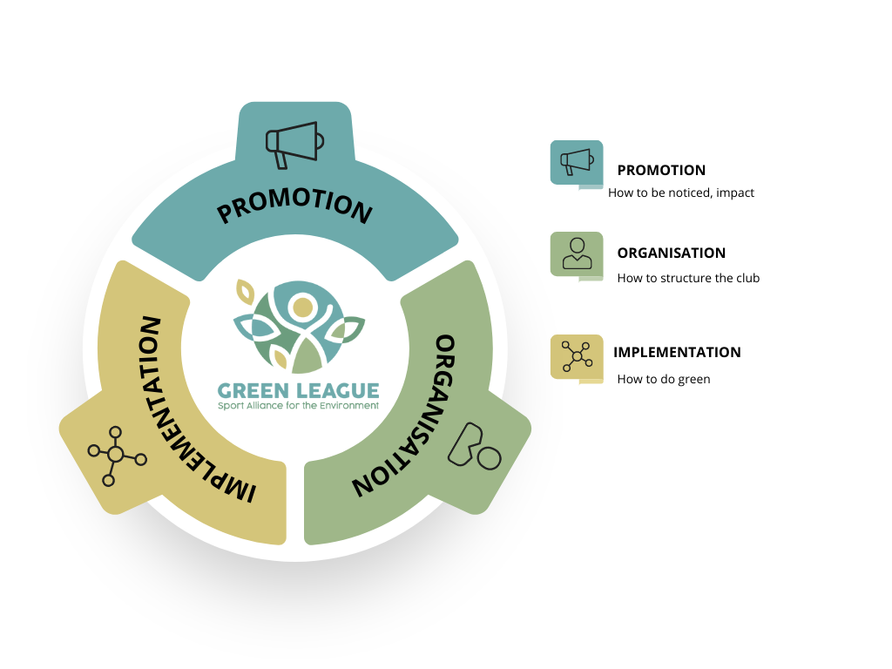

Organisation
The first aspect of the Green League model focuses on the structure of the organisation. This involves creating a culture of sustainability within the organisation (sport club). This involves incorporating sustainable practices into the organisation's policies and procedures, as well as establishing environmentally friendly practices into the day-to-day operations.
The organisational base of a green sports model consists of several key elements, including existing legislation/policies and directives, stakeholders and level of operation.
For further information go to page 17 of this document.
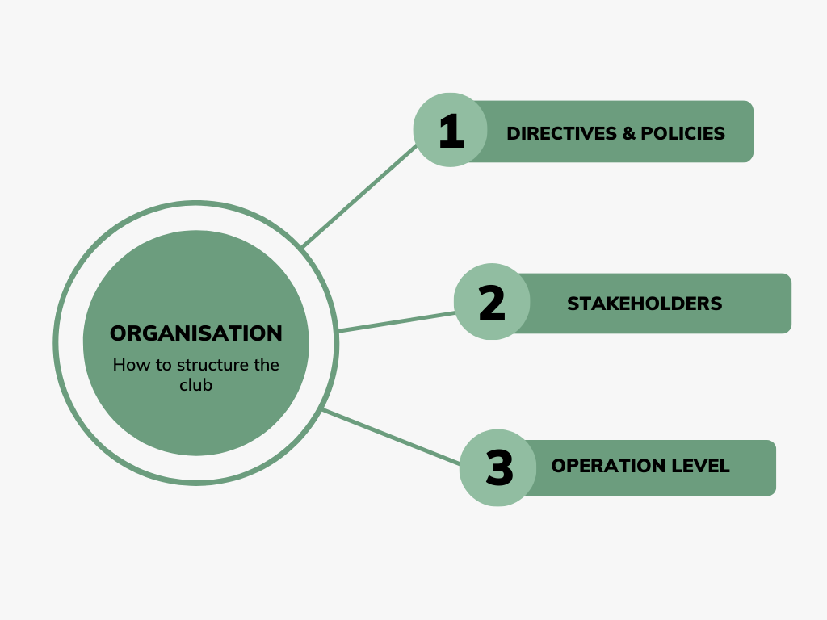
Directives and Policies
To structure a green sport organisation, it is essential to be aware of any national or international directives and policies related to sustainability. Sport organisations should adhere to these directives and policies to reduce their environmental impact.
There are various directives and policies that are being established at both the national and international levels to promote green sports.
The sport organisation itself should also have a policy of operation. The policy of a green sports organisation should be centred on sustainability and environmental responsibility. This policy should guide all activities and decisions of the organisation, and should be communicated clearly to all stakeholders.
For further information go to page 17 of this document.

Stakeholders
To be successful, green sport organisations must engage and involve various stakeholders, including sport organisations, the local community, athletes, fans, sponsors, public authorities, and intermediaries/supporters.
Sports organisations should partner with environmental organisations to help create policies and promote sustainable practices. Engaging the local community is also essential to promote sustainable practices, raise awareness, and encourage participation in green sport activities. Intermediaries and supporters, such as sponsors and vendors, also play an important role in promoting sustainable practices.
For further information go to page 19 of this document.

Incentives and benefits
Green sports organisations should consider the reach of their activities and the level of commitment required to promote sustainability. This includes international, national, and local levels.
Thus, the level of operation of a green sports organisation can vary, from local grassroots organisations to large international associations. The organisation should operate at a level that is appropriate for its resources and goals, while still promoting sustainable practices in sports.
At the international level, sports organisations can promote sustainability by adhering to international policies and partnering with environmental organisations. At the national level, organisations can implement sustainable practices and policies that adhere to national directives. At the local level, organisations can engage the local community and promote sustainability through grassroots efforts.
For further information go to page 22 of this document.

Implementation
The basis of a green sport model involves the implementation of sustainable practices throughout the sporting organisation and requires several key elements to be kept in mind, including: the impact of sport on the environment, the potential of sport for environmental engagement, the planning and implementation of green sports, the type of activity, and the principles and goals.
For further information go to page 23 of this document.
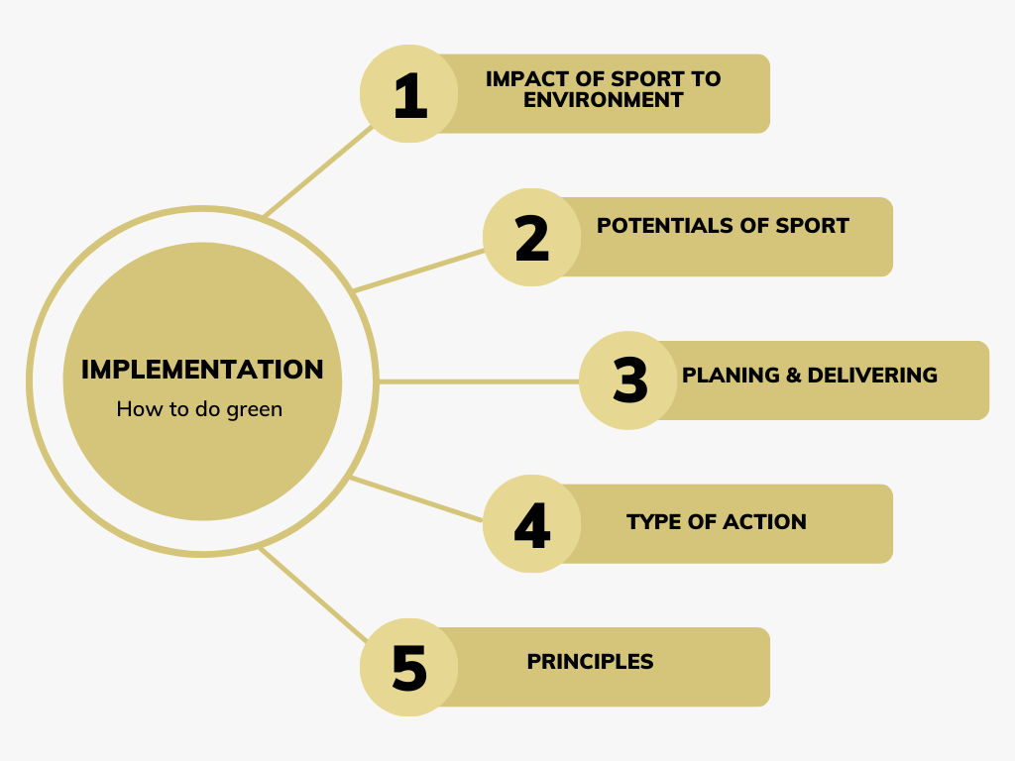

How sports impact the environment
Before implementing sustainable practices, it is essential to understand the impact of sports on the environment. Sports events and activities can have a significant negative impact on the environment. Understanding these impacts can help organisations create effective sustainable policies and practices.
For further information go to page 23 of this document.
The potential of sport for environmental engagement
Green sports have the potential to create a positive impact on the environment and social and economic systems. They can also promote healthy and sustainable lifestyles, improve social cohesion and generate economic benefits. Sport can be a powerful tool for raising awareness and promoting sustainable practices. Green sports initiatives can inspire fans, players and other stakeholders to adopt sustainable practices in their daily lives.
For further information go to page 24 of this document.
Planning and implementation of green sports events
To plan and implement green sports activities and events, clubs can adopt a sustainable framework that includes policies, goals, and action plans. The framework can focus on various aspects such as energy and water conservation, eco-friendly food and beverage options, waste management strategies, sustainable transportation and procurement. They can also implement green procurement policies for products and services. This includes sustainable sourcing of materials for equipment and infrastructure.
For further information go to page 26 of this document.

Types of Action
Green sports activities should involve the entire sports chain, from design and construction to operations and post-event management.
Organisations can undertake different types of actions to promote green sports, such as awareness-raising activities, events and infrastructure projects.
Awareness-raising activities, such as workshops, seminars and campaigns, can promote sustainable practices and encourage participation in green sports activities.
Events, such as green sports tournaments or green sports competitions, can also promote sustainable practices and create awareness on environmental issues.
Infrastructure projects, such as green stadiums or solar-powered sports facilities, can also promote sustainable practices and reduce the environmental impact of sports activities.
For further information go to page 33 of this document.

Principles and goals
The principles refer to two aspects. The goals we want to achieve through green sports at a general level and the principles of event implementation, which refer to the objectives of the event itself.
Green sports activities and events should prioritise safety, inclusion, equality and collaboration, as well as promoting sustainability. By following these principles, organisers can create a safe, welcoming and sustainable environment for all participants, spectators and stakeholders.
For further information go to page 36 of this document.

Promotion
Promotion includes the process of sharing information and spreading the message of green sports. Promotion activities must be tailored to the needs of each stakeholder and may include information on the sports organisation's policies, social media campaigns, e-newsletters, conferences and other awareness-raising activities.
The final aspect of the Green League Model involves promoting sustainability both within the organisation and externally. This may involve marketing sustainable products or services, participating in environmental campaigns or initiatives, or working with other organisations to promote sustainability.
The basis for promoting a green sports model consists of several key elements, including: media, communication, education and advocacy.
For further information go to page 38 of this document.

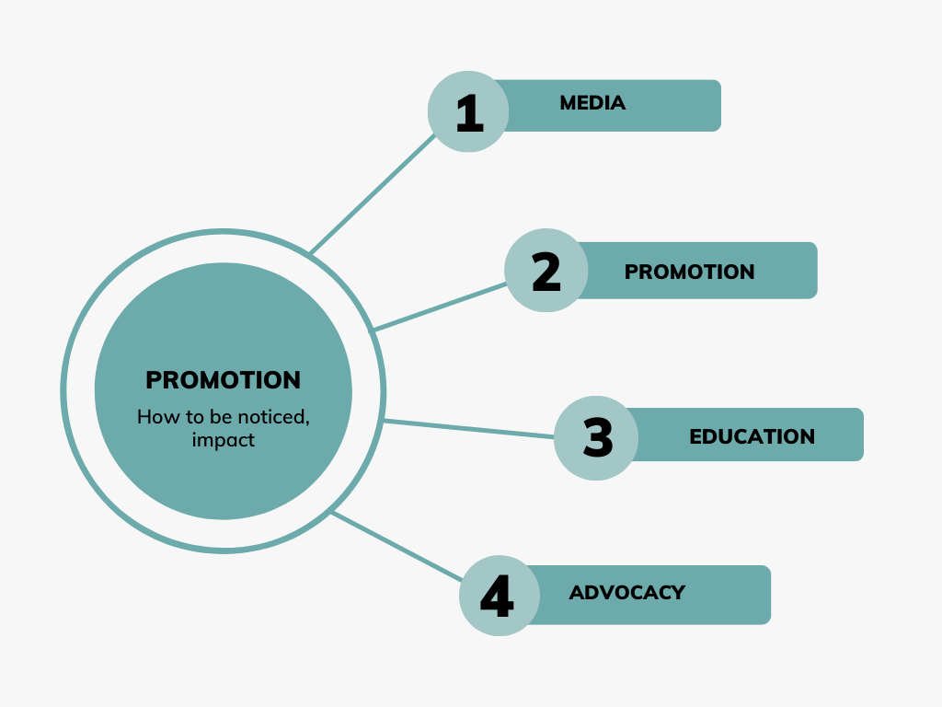

Media
Media can be important partners in promoting green sports and raising awareness on the environmental impact of sports activities. Green sports organisations should seek to engage with the media and use them as platforms and tools for promoting their activities.
For further information go to page 38 of this document.
Communication
Communication is key to promote the message of a green sport organisation. The organisation should work to clearly communicate its policy and goals and ensure that stakeholders are aware of the benefits of sustainable practices. Communication should be transparent, informative, and engaging, and should be tailored to the specific needs of each stakeholder group, including athletes, fans, sponsors, and the community at large.
For further information go to page 39 of this document.

Education
Training and capacity building are essential to ensure that green sports practices are adopted and maintained over time. Examples include training athletes and coaches in sustainable practices, building the capacity of facility managers in the design of green buildings, and educating fans about the environmental impact of sporting activities.
For further information go to page 41 of this document.
Advocacy
Advocacy can be described as an activity that aims to influence actions and decisions inside the political, social or economic system addressing a particular issue.
For further information go to page 43 of this document.

Organisation

How to structure sport clubs to be green

Directives and Policies

The EU is in charge of developing policy and fostering cooperation and initiatives in support of sport across Europe.
The European Union did not have an official EU sport policy until the adoption of the Lisbon Treaty in 2009. Until that milestone other EU policies had an impact on sport. The case-law of the European Court of Justice (ECJ), Bosman ruling (1995), stretching from Walrave (1974), and the Meca-Medina (2006) ruling have shaped the EU’s influence on sport. The European Court of Justice made a ruling that sport, whenever constitutes an economic activity, has to comply with EU law.
The White Paper on Sport set the basics of the development of the EU sport policy, followed by the 2009 entry into force of the Lisbon Treaty and adoption of three EU Work Plans for Sport by the Council of Ministers (2011-2014, 2014-2017 and 2017-2020).

In the Resolution of the Council and of the Representatives of the Governments of the Member States meeting within the Council on the European Union Work Plan for Sport (1 January 2021-30 June 2024) 2020/C 419/01 one of the guiding objectives is to:
‘’Increase participation in sport and health-enhancing physical activity in order to promote an active and environment-friendly lifestyle, social cohesion and active citizenship’’.
One of the Priority areas: ‘’Socio-economic and environmental dimensions of sport’’ includes
‘’Green Sport’’ with aims of:
- Education for sustainable sport,
- Environmentally friendly sports practice, facilities and events
- Evolution of sport and its practice in the light of climate change.

In 2001, the EU adopted a regulation allowing both public and private organisations to implement the Eco-Management and Audit Scheme (EMAS).
In 2000, the EU adopted a regulation on a revised Community Eco-Label Award Scheme. The Commission has also adopted a non-binding handbook on environmental public procurement (“Buying green!”). This document is particularly pertinent for local authorities that are planning to award contracts for the construction or renovation of sport facilities.
Where plans or projects are necessary, e.g. urban development projects such as the construction of infrastructure for the organisation of sport events, competent authorities and concerned parties need to implement the Environmental Impact Assessment Directive and the Strategic Environmental Assessment Directive.

The EU's "Green Deal" and the European Green Deal's Just Transition Mechanism emphasise the need for sustainable practices across different sectors, including sports. The Sport Sector's can also benefit from Policy Measures under the Recovery and Resilience Facility (RRF) and other programmes like Erasmus+.

The EU fosters the idea of improvement of the general well-being, overcoming societal issues (e.g., racism, social exclusion, gender inequality, etc.), and economic benefits through sport. Sport policy plays important role in the EU’s external relations within three aspects:
- the societal role of sport;
- its economic dimension;
- the political and legal framework of the sports sector.
These objectives were endorsed in the first comprehensive initiatives on sport: the White Paper on Sport and the Pierre de Coubertin Action Plan, developed in 2007.

For further information of directives and policies at EU level with a special focus on the ones in Italy, Slovenia, Cyprus, Greece, Iceland, Belgium, go to Sport and Environment Training Package – Module 3.

Examples of international sport initiatives and stakeholders
- UNESCO - International Charter of Physical Education, Physical Activity and Sport
- United Nations - Sports for Climate Action Framework
- Olympic Charter
- Youth Ideas Labs 2022
- SHARE - Green transition and sport at all levels
- European Olympic Committees – EOC the umbrella body for Europe’s 50 NOCs committed to spreading Olympic values and inspiring sporty lifestyles.
- ENGSO (European Non-Governmental Sports Organisation)
- International Sport Organization
- Olympic Movement's Agenda 2020
- Green Sports Alliance
- Sport and Sustainability International
- World Sailing Sustainability Agenda 2030
- FIFA's Sustainability Strategy

Stakeholders

Today, it is no longer possible to meet today's environmental challenges alone. An integrated approach is needed to achieve the ambitious goals of the 2030 Agenda: sports associations and clubs must work together with organisations, companies, institutions, associations and the entire community to achieve a broader goal of respecting and protecting the environment and generating impact.

Organisations
Stakeholder engagement is a process used by any organisation to achieve a common outcome. Stakeholder engagement also enables an organisation to better identify and understand their sustainability concerns and expectations and respond to their actions and decisions.
The process is divided into 4 phases:

- The first phase concerns the definition, identification and mapping of significant stakeholders, that are those social actors that are part of various organizations on the territory, establishing adequate indicators and sharing through listening to the sports management, the parents' group and other networked organizations.
- The second phase consists of planning, i.e., devising the right strategies and choosing the right tools, considering all internal and external resources. At this stage, it is useful to anticipate possible risks related to stakeholder involvement in the operational phase, remembering that the process is never static but dynamic.
- The third phase involves the development of a detailed plan for the operational management of stakeholder involvement. Three levels of involvement are envisaged for this phase: monitor, inform, collaborate based on the degree of stakeholder participation (from passive to active).

  - Monitor the social needs and demands of the organisations and the sports world, through digital tools;
  - Consult and inform the most relevant stakeholders, through reports and events to be advertised through social networks;
  - Involve and collaborate for the realisation of common projects on sports issues in harmony with the environment and other possible useful initiatives for liaison work;
- The fourth and final phase consists of reflecting on the initiatives and evaluating what has been learnt in order to refine and improve it for use in subsequent stakeholder engagement processes.

Local Community
A community is a group of people who share common characteristics or interests, it is not only a part of territory, land or city. Examples of local community are:
- The school with families;
- Universities campus;
- Sport clubs with families;
- Groups of volunteers;
- Clerical communities;
A community can be so defined by interest in common, geographical location, age, occupation, affinity or other common ties, in our case a mission for environment and interest for sport.
Communities also include local authorities, that are citizens (or specific associations, organisations) who have a role in making decisions and having influence at a wider level.
For this reason, the strengthening of the role of each part of the local community can be fundamental to fit into a system of environmental impact of its own initiatives, as a sport organisation.
But in order to play this role to the full, it is necessary for each actor in the local communities to be able to develop networks and involve the local community:
Step 1: Involve community.
Community involvement is a dynamic and complex process that is often associated with different concepts such as "community participation", "mobilisation", "empowerment".
Step 2: Create new networks (or reinforce existing ones).
Networking requires involvement at all stages, especially in the definition of objectives and the planning of interventions. The process of networking is always bilateral: co-participation (such us, in the events organised by each part) and co-planning, for new initiatives or strategies.
Co-planning is not easy since requires experience, but it is one of the challenges to make all the protagonists feel part of the network.
The perspective is therefore collaboration among institutions, local authorities, environmental organisations, families, schools, citizens, civil and religious associations, that:
- create alliances
- collaborate
- participate
- co-plan
- share ideas
With sport clubs or organisations to carry out green initiatives or events but especially work on direction and strategies to generate environmental and sustainable impact.

Tips for sport organisations:
Step 1. Follow the social media pages of organisation active in environmental issues
Step 2. Go to events, initiatives organised by them
Step 3. Invite relevant citizens or associations during your initiatives
Step 4. Start a collaboration: put the basis for alliances
Step 5. Be persevering

Supporting partners
In the light of the above, associations and organisations sensitive to issues of respect and environmental protection are able to make alliances on the territory and to propose co-projects to apply for funding to local authorities and private foundations that support initiatives in favour of sport and the environment.
In Europe there are a lot of financial programmes that allow funds for activities about the environment and ecological transition, which could be a useful strategy to transform one's own sports organisation in the light of greener addresses.
The search for funds, moreover, can regard a relationship with sponsors, that is private (usually companies) that economically support events, ideas, laboratories on environmental and sports issues.
One idea could be to strengthen contacts with some prominent national, regional or local association (such UICN, Greenpeace, WWF and so on) to receive support, sharing ideas for joint initiatives or personal events planned by own sports association, in order to start the change and create new initiatives more environmentally friendly.
Remember: networking and partnership are essential in the funded projects!

Incentives and benefits
Going green is a path that requires different efforts depending on the sports club. For a small club that often does not have many resources, going green means overhauling everything. It can be quite expensive financially, and the argument that the cost of "doing it right" is not valid due to lack of resources, so it is good to examine what is gained by going green, beyond being more environmentally friendly. The benefits of going green are many and can be financially advantageous. There are many international and local incentives to go green. In the following, we will look at international, national and local incentives.

International
UN Climate Change launched an initiative called “sport for climate action” that aims at supporting and guiding sports actors in achieving global climate change goals. This gives sports organisations the opportunity to be leaders in the world's green movement. This will unite sports organisations and their communities to be an example for future generations. The UN asks organisations to commit, but offers no financial gain for adopting a green approach; however, it represents a public relations opportunity and can draw attention to sports organisations. If approached in the right way, it can be an opportunity to win over both domestic and international fans, which can create long-term revenue, as well as create a network of clubs that share the ideals of ecology and can help in the long run to have a close association with the club.
When you commit to going green you are becoming an example for others, both people and organisations. Going green is not a national problem or local problem, it is an international problem and people are more aware of it every day. Your change can line you with a bigger target group

National
What help is available to go green varies quite a lot from country to country. The biggest impact nationally is, as stated before, that it is that you are a role model for. It depends on how large the organisation is, however this can elevate the sports organisation to the public eye with their actions.

Local
At the local level, sports organisations can engage in various activities to create a positive impact within the community. Recognising that local communities play a vital role and that changes in mentality within the organisation can foster a sustainable environment, sports organisations can initiate transformative changes that go beyond the club itself.
Sports organisations can become agents of positive change within the local community. A change in mindset and attitude within the organisation can create a ripple effect, transforming the culture of the sports organisation and positively influencing the entire community. Through inclusive programmes, outreach efforts and partnerships, sports organisations can actively contribute to the betterment of the local community and inspire other organisations to embrace similar changes.

Implementation

How to organise green sports activities and events

How sports impact the environment
Every action we do has an effect on our surroundings, no matter if we notice it or not. With that in mind some actions have more effect on the environment than others. Sports are not different; each sport impacts the environment differently depending on the sport. The last decades there has been more awareness of the environmental industry yet there has not been much change within the sports industry to combat it.
The UN addressed the important part that sports can have in the future of climate change with both the influences sports have in society and their own emissions. Sports are quite a vast area and vary quite a lot, that does not mean that only the highest emission sport should take responsibility and act. In every sport, actions can be taken to lower the emission of it, both on the professional level and amateur level. It is important when looking at professional sports to also look at the impact of the spectators as they count in the effect of the sport and that is why The Olympics in Rio had 3,6 million tons of carbon dioxide released in the atmosphere and 2,16 million at the FIFA World Cup in Russia in 2018. It is easy to focus only on the negative parts of sports and in general how we affect the environment. It is important though to look at the positive impact also. Sail of Change claims that outdoor sports increase the connection between people and the environment around them. This connection between people and nature has faded more and more with large quantities of populations living in cities with no daily interaction in green areas.

Good practices
It is good to look at actions being done in the sports industry the last few years at the international level like the Olympics which have the goal of being carbon negative at the 2030 Olympics. This shows that action is being done at the highest level of sports to combat the environmental changes but there are also actions being done at the local level. Some practices at the local level are represented by changes in the structures of sports clubs such as the Forest Green rovers, they changed the infrastructure of the club to be more eco-friendly. Other clubs and industry had to change due to change in the climate like Las Vegas golf courses where with the lack of water supply, they changed grass to artificial grass to lower the water usage. All these actions are something other clubs can look at and adapt as their own in some part.

For further information read the Sport and Environment Training Package –Module 4.

The potential of sport for environmental engagement
The potential of sport engagement in environment preservation and sustainable development is highlighted in this section. Sport is recognized as an effective tool for achieving global goals, such as combating climate change and promoting social inclusion. The United Nations has adopted the Sports for Climate Action Framework, which aims to reduce emissions in the sports sector and raise climate awareness. The International Olympic Committee has also played a key role in promoting sustainable development through sports.

Sport and sustainable development goals (SDGs)
Sports can contribute to various Sustainable Development Goals (SDGs), including health and well-being, gender equality, quality education, sustainable development, social inclusion, and peace and justice. Additionally, sports can have significant environmental potential, such as promoting green infrastructure, sustainable transportation, waste reduction, energy efficiency, conservation and restoration, and green innovation.
To achieve sustainable development through sports, collaboration and partnerships among various stakeholders are essential. Sport organisations, authorities, and other stakeholders should develop sustainability strategies focusing on sustainable practices, community engagement, and inclusivity. Policies that incentivize collaborations and partnerships, as well as the participation of all stakeholders, are crucial for accelerating progress towards sustainable development through sports.

Sport environmental initiatives
Sport environmental initiatives have gained momentum, with organisations like the International Olympic Committee, UEFA, and Sport and Sustainability International (SandSI) and others, leading the way. Efforts are being made to reduce the environmental impact of sports events and venues, promote sustainability in the sports industry's supply chain, and mobilise fans and athletes to support sustainable communities.
Environmentally friendly planning of sports infrastructure is important to minimise the environmental impact. This includes site selection, sustainable design, green landscaping, water and waste management. By implementing sustainable practices, sports facilities can reduce their environmental footprint and promote sustainability.
When planning sports infrastructure in nature and built-up areas, factors such as the resilience of the natural area, traffic connection, and organising activities in a way compatible with nature and the environment should be considered. Providing adequate and attractive sports facilities in built-up areas can help reduce the need for transportation and promote physical activity among residents.
Overall, the potentials of sport green involvement in sustainable development are significant, and efforts are being made to harness the power of sports to address global challenges and create a more sustainable future.
For further information read the Sport and Environment Training Package – Module 5.

Planning and Implementation of green sports events
Sustainability is a process, not a status; in fact, most aspects of the sports sector may never reach a point of true environmental sustainability. Consequently, environmental sustainability is understood as a commitment to consistent progress toward Sustainable Development Goals (SDGs) by reducing the carbon footprint and engaging meaningfully in the sports sector’s ongoing efforts to mitigate environmental risks, especially the ones of sports events.
In this chapter, can be found tips and guidelines that can be applied when working on funding, venue and supplies selection, transportation options, and your event communication. Keep in mind that these ideas are intended to get you started, so the lists are not all-inclusive.

Getting started
Before getting deeper into your organisational plan, it is important to know and understand the value of promoting a sustainable event, the “why's” that will lead your decisions and actions. These “whys” can be better understood by examining the connections between:
- your stakeholders’ interests and expectations
- the major sustainability issues related to your sport and your event
- the relevant risks and opportunities
Engaging stakeholders (i.e., individuals or groups that have an interest in any decision or operation related to your event, like local authorities, sponsors, athletes, media, NGOs, and suppliers, see previous chapter for and insight) in a two-way conversation and an open dialogue constitute one of the most effective ways of preventing setbacks by collaborating with them, establishing a common ground and creating solutions. So, list the stakeholders that:
- influence the way you manage your event
- have significant expertise to share
- are most likely to be affected by your actions, listen to them, integrate their comments in your action plan and publicly acknowledge their contribution.
For the identification of the sustainability issues related to the potential economic, environmental and social impact of your event, you are encouraged to:
  - Think about the goals of your event and the main activities required
  - Ask yourself and your team about the necessary resources, the venue, the transportation, the waste management afterwards, the economic value and its distribution, and the impact on the host community
  - Then, share your ideas and get feedback from the relevant stakeholders you have already engaged in your event.
Finally, you have to assess the potential sustainability risks and opportunities related to the operation of your event/activity which can be:
- Strategic, e.g., damage to reputation
- Financial e.g., attracting sponsors
- Natural and “force majeure” e.g., fire, floods, boycott/strikes
- Operational e.g., logistics, safety, sites

Green recommendations for sports events
After mapping your stakeholders, your needs, challenges and opportunities, you should have a brief idea of how to approach your event. This section aims to provide you with green recommendations for key aspects of an event. Try to keep in mind that the lists below are not exhaustive and you may have to adapt the ideas to best suit your sports event.
Site and Venue
- Choose existing sites and venues where possible
- Implement a no-smoking policy
- Use biodegradable cleaning products
- Limit the use of vehicles on-site by securing safe parking lots nearby
- Reduce and prevent noise through signage, respect by-laws, training and inspections
- Respect local culture and heritage and avoid using spaces with environmentally sensitive ecosystems
While picking the venue ask yourself:
- Is it centrally located? Athletes, officials and spectators should have short and/or convenient commuting distances.
- Is it serviced by accessible public transportation?
- Is it safe and secure for participants, organisers, employees and the community?
- Is it accessible to all participants (e.g., wheelchair accessible)?
- Is the necessary venue and equipment already in place?
- Is there evidence of a sustainability policy in place and use?
Transportation
- Provide spectators and athletes with information, guidelines, education and incentives to use public transportation services.
- Liaise with the local public transportation authorities to ensure sufficient, affordable and effective modes of public transportation.
- Provide information and maps of paths and cycle routes.
- Offer supervised bike parking or put in place a bike lending initiative during the event.
- Use low-emission shuttle vehicles, hybrid and electric cars during your team’s transportation.
Food and Beverages
- Promote and support healthy diets with healthy and low-impact choices (e.g., fruits, vegetables, grains, and other fresh, low-sugar, low-sodium, trans-fat-free, and unprocessed food).
- Remember to provide safe drinking water at all event sites and venues by equipping the venue with water-saver taps.
- Respect athletes’ special dietary requirements.
- Source from fair-trade, organic, seasonal, local and regional sources as much as possible.
- Distribute food with biodegradable, recyclable and/ or minimum packaging.
- Provide compostable or collapsible cups instead of plastic ones.
Energy and Waste management
- Operate site and venue lighting, cooling and heating optimally.
- Reduce water usage and use water from renewable sources.
- Include stormwater capture and reuse; low-flow toilets and no-flow urinals.
- Buy what you absolutely need.
- Consider what you provide to competitors and whether it can be replaced by plastic-free alternatives. One option is to provide a practical item (e.g., reusable water bottles) for competitors to take away, rather than an object for display (e.g., a medal).
- Waste that cannot be avoided should be reused, recycled or sent for composting.
- Keep the site and venue litter-free through efficient use and placement of garbage and recycling bins.
- Prepare stickers to aid the visibility of the separate waste and recycling bins
- Donate clothing and equipment to local sports, community organisations, or second-hand shops.
- Ask caterers to donate unused food to local shelters.
Funding and Supply chain
- Seek sponsors with the commitment and capability to help achieve sustainable sport events (e.g., low waste and low carbon solutions, ethical sourcing and sustainable operations).
- Identify organisations in your community that are working on climate action to find opportunities for collaboration.
- Make sure that your suppliers conform to national/European codes of conduct (the EU Code of Conduct on Responsible Food Business and Marketing Practices can be found here).
- Use local organisations for temporary jobs, volunteers and contractors and ensure a fair wage system.
- Collaborate with local enterprises and those that support diversity and people with diverse backgrounds.
- Discuss with your sponsors how best to ensure a plastic-free and sustainable vision is maintained while still promoting their businesses.
Communication and Dissemination
- Choose a few focused messages and use them throughout the event. Be careful not to “greenwash”, by overusing terms and images that are not accurate or overselling an organisation’s environmental practices.
- Implement electronic systems for event registration, communications, finances, and certificates of attendance where possible.
- For the evaluation process, create QR codes that will lead to online evaluation tools (e.g., Google Forms) and will be available in certain spots in the venue.
- Avoid unnecessary paper, flyers, and mail-outs.

How to implement sports events in nature combined with environmental reflection
When we organise sports events, usually we follow a structured way of organisation that tends to be the same at every sports event. For example, you may have a standardised method to organise a football game or a running race. However, is the environmental impact of the sports event considered in that method? Probably not, but there is always space for improvement on that.
Organising green sports events and activities is important, not only for the sports club and associations, but also and mostly for the participants, amateur athletes, young people and their families. Raising awareness on environmental issues and on the link between sport and environment, educate and pass knowledge and information to young people, their families, amateur athletes, it is of fundamental importance in order to spread the green message at multiple levels. Especially when it comes for young people, the sooner they get this knowledge the bigger the impact will be in the future at both small a large scale.
Organising sports events combined with environmental reflection is thus a way to raise awareness on environmental issues, in this case acting at participants’ level.
In order to organise sport events in nature combined with environmental reflection, it is advisable to incorporate the following questions in the event’s organisation:
- What can be the impact of your sport in the environment?
- How the sports events that need to be organised for your activity, can influence/change/disrupt the natural environment?
- What should I change in my practices in order to have limited environmental impact while organising, implementing and finalising sports events?

In addition, the Green League Model suggests that sports events could include the sports activity & one educational and experiential learning component that will bring group reflections on how to reduce sports’ impact on the environment while directly living that particular environment.
During the sports practice, you can draw participants’ attention to specific environmental challenges or features related to the sport they are practising. Following the sports activity, non-formal education and reflection activities on the surrounding environment can take place e.g.:
- discussions in a circle on forest environment
- explanation of the role of that ecosystem for the environment
- reflection on the pollution caused by the sports event
- brainstorming on how to preserve the environment when practising sport
- group discussion before or after the sports event e.g., running race, within your club/team to reflect on the environmental impact of your event; ways of improvement; and actions to be considered for the next sports event you will organise
- reflection on the role of the ecosystem/s in our daily life and the way that anthropic actions may impact on their functioning
Finally, these questions and methods are indicative actions that sports organisations and sport professionals could do in order to implement sports events with environmental reflection. You may have other innovative ideas also that could be used!

How to organise sport events combined with environmental actions
The organisation of sporting events, combined with sustainable activities, helps bring young people closer to nature so that they can become aware of the importance of caring for the environment, in any area and ecosystem. Sport is in fact an essential element in transmitting the values of environmental protection in an enjoyable and fun way, which has the power to involve young people in an active and conscious manner.
These types of activities can be organised with a wide range of different age groups from all social and cultural backgrounds. These activities also attract, not only sport lovers, but also people who care about environmental issues. Moreover, implementing activities that combine sports with environmental actions, not only increase awareness on the importance of preserving the environment and protecting it, but at the same time, these serve as physical activities that are good for health.
Therefore, combining sport and environmental actions provide a double positive impact, on one side on environment protection and on the other side on human beings’ health and wellbeing.
Sport and environmental mini-tournaments
Organising sports competitions and mini-tournaments that include good environmental practices, promotes healthy, fair and inclusive competition. Indeed, it is necessary to work together to create a clean environment before starting, with the cleanliness of the playing space, and with the knowledge that no litter should be thrown during the tournament, results in less fatigue at the end of the tournament. The sports events, in fact, can be accompanied by clean-up activities at the venue, both before the event and after its conclusion. In this way, participants will be more aware that taking care of the environment reduces the effort to make it clean again and at the same time, they give the “example”, being the audience watching what they are doing and so spreading the message that it is important to not have a negative impact on the environment we are in.
There is a high flexibility in organising such sport competition; the type of sport and the period of competition organisation can be chosen according to environmental factors, available venues and the interests of the young people involved. Of course, it should be kept in mind that, in order to combine mini tournaments and competitions with environmental actions, the sport should be played in an outdoor environment, anyway, it is not mandatory to be in some natural place, also our cities deserve to be kept clean, since what we leave in the streets or sidewalks, may arrive to the ocean or to forest and wood through rain flows or windy days. Therefore, doing the activities inside cities, can also provide more environmental awareness to people, making people reflect on the fact that also small actions in one place can have big negative impacts far away.
Combining the competitive funny side of the sport and the environmental actions and critical thinking is a good way to learn while practising and having fun. For this reason, in this case it is that the chosen activity is a team-sport: football, volleyball, basketball, handball, cricket, water polo, rugby, etc… so as to also create a sense of collaboration, a group that is running toward the victory, not only by winning the competition, but also by cleaning-up the environment. To do so, a hybrid scoring system that counts not only sport points but also environmental points, needs to be foreseen (see next paragraphs on “hybrid scoring system”).
Sport and environmental relay races
The relay races are another example of combining sport and environmental action; in this case, the sense of group, community and collaboration is given by the fact that a relay race encourages cooperation between the young people involved. In addition, thanks to the relay race format, the idea that the action of one person has consequences on the actions of other persons, is underlined.
This type of activity is inspired by the 'Plogging' discipline (pick up trash while jogging), preceded by a waste collection activity and using the collected waste bag as a symbolic baton to be passed. The message being conveyed is the enhancement of good environmental practices that ‘add up’ to the purely competitive score.
In the case of combining sports with environmental actions, the relay races will see a winning team, that will not be the first to finish the race, but it will be the combination of waste collection and best scores (see paragraph on “hybrid scoring system”).
The planned activity is a 'race' but can be adapted to the availability of the venue: it can be organised on road, land, water, in different modes and at any time of the year.

Hybrid scoring system
When organising sport tournaments and relay races combined with environmental actions, as mentioned in the previous paragraphs, it is important to foresee a scoring system that combines points for both, to emphasise both actions: the sporting and the environmental one.
The hybrid scoring system is a proposed system, designed to combine environmental actions and sports results, where each team receives both “green points” and “sport points”.
The hybrid scoring system could be based on:
- Awareness Video messages (i.e.: 1 “green point” for each video published)
- Trash bags (i.e.: 1 “green point” for every filled bag)
The final score in this way will be calculated considering sport points (i.e.: number of goals in football) + green points. Follow examples to give an idea of how it could be done.
TEAM SPORTS - Final score = Sport points * Green points
Example: Volleyball match
 | Red Team | Yellow team
Match score | 3 | 2
Video published | 5 | 9
Filled bags | 2 | 2
Final score | 3 * (5+2) = 21 | 2* (9+2) = 22
The example shows that even if the red team won the match, the final winner is the yellow team, due to the green points collected.
NB: If one of the 2 categories is “0”, the final score will correspond to the actually scored points.

RELAY RACES - Final score = final time of the race – (n° of bags * ½ second)
Example
 | Red Team | Yellow team
Time | 57 sec | 56 sec
Filled bags | 4 | 1
Final score | 57 - (4 * 0,5 ) = 57 – 2 = 55 | 56 - (1 * 0,5) = 55,5
The example shows that even if the yellow team won the match, the red team is the final winning team because collected more trash.
The final scores will be calculated after the end of the competitions, in order to declare the winning team for each category.

Types of Action
Sports associations at the local level represent the foundation of the entire sport. Bringing together and representing a large number of people enables clubs and gives them the opportunity to influence local and wider politics to adopt appropriate policies and measures, as well as promoting and implementing environmentally friendly activities and encouraging a positive attitude of participants and general public towards the environment.
We highlight three forms by which sport clubs at the local level can reach these sustainable goals.
- Awareness Raising activities
- Events and sport activities
- Infrastructure

Awareness Raising activities
Public awareness is important to increase enthusiasm and support, stimulate self-mobilisation and action, in order to achieve common goals. Raising political awareness is important as policy makers and politicians are key actors in the policy process of adaptation.
The ultimate aim of such awareness raising activities is to achieve long-term lasting behavioural changes of individuals and organisations. It aims to ensure that all relevant stakeholders understand the issue and take action to respond properly.
Awareness raising activities sport clubs can perform include, but are not limited to:
- Sport club policy
Adopt guidelines and formulate rules for the operation of your club and all members, which will be aimed at the implementation of all activities and programs of the association, so that environmental protection measures will be taken into account.
- Regular awareness campaigns
Several times a year, organise activities where you draw attention to environmental protection issues. You will increase the effectiveness of the campaign by using various means of communication: press, informational posters (using recycled paper or e-posters), eco-T-shirts, social media, public debates, etc.
- Website and social media
Design a website that reflects your environmental orientation, use social media and your networks to distribute your messages. Organizing social media contest may also be great way to raise awareness.
- Speak outs
As part of your activities, address your members and the public, highlight the issue of environmental protection and call for action.
Some examples:
Climate ADAPT
Ecosphere+
SportandDev

Events
Sports events and regular sports training activities are the basic way through which sports associations can realise the guidelines of environmental protection and actually implement environmental protection measures and stress the use of greener resources.
Successful implementation of any program requires planning. To get your program green, you need to plan for the following:
- Targeted measures
The measures that you can address with your program and activities can relate to general environmental protection, preservation of clean water, renewable energy sources, reduction of the carbon footprint, reduction of waste, etc.
- Stakeholders
For a successful implementation, wider support is needed: volunteers who will do the necessary work, financial supporters who will provide the necessary financial and material support, media supporters who will ensure the necessary promotion, transport that will be environmentally friendly, waste management, use of environmentally friendly materials (e.g., paper cups) etc.
- Implementation
Depending on the goal of the program/event and the target group, it is necessary to choose the place of the event or program that will ensure the greatest impact and visibility.
Communicate the purpose and goals of the program/event appropriately.
Provide eco-friendly choices, e.g., transport, recycling bins, etc.
Define how to measure the effects and present the results.

Some examples:
Responsible sports events
SFORAE
Going green: How to host an eco-friendly event

Infrastructure
Sport infrastructure plays a crucial role in sport. Most modern sports require some kind of infrastructure (e.g., athletic stadium, basketball hall, etc.) without which the sport cannot be played. Even sports that can otherwise be practised in nature require some kind of space arrangement (e.g., cross-country skiing, motocross, kayak/canoe, etc.).
Caring for the environment starts at the local level. Bringing together and representing a large number of people also gives clubs a great influence in the local and wider environment and gives them the opportunity to influence local and wider politics to adopt appropriate policies and measures.
Sports organisations and associations thus have an exceptional opportunity and, at the same time, a duty to influence the placement and construction of sports infrastructure at the local level. The key factors that associations can highlight are:
- Planning of sports infrastructure
From placement in the room to the use of environmentally friendly materials and construction methods.
- Use of energy efficient measures
From the installation of renewable energy sources, such as wind and solar, to the use of environmentally friendly energy consumers, such as energy efficient lighting, heating and cooling,
- Water use and waste management
- Transport accessibility
Placement of infrastructure in a space that enables easy and quick (short) access and use of environmentally friendly forms of transport (bicycle, foot) and public transport.

Some examples:
Green Technology tips
Sustainable infrastructure
Strategic Policies for Sustainable Infrastructure
How to Design a Sustainable Sports Facility

Principles and goals
The goals that we want to achieve through green sport on a general level are linked to the principles of the implementation of the event, which refer to the goals of the event itself.

Principles of Green Sport
The United Nations Framework Convention on Climate Change (UNFCCC) established an international environmental treaty to combat "dangerous human interference with the climate system", in part by stabilising greenhouse gas concentrations in the atmosphere. It was signed by 154 states at the United Nations Conference on Environment and Development (UNCED), informally known as the Earth Summit, held in Rio de Janeiro from 3 to 14 June 1992.
Sport is, beside the fashion industry, the sector where climate action initiatives were initiated. Uniting behind a set of principles, sports organisations and their communities have created an initiative by collaborating in order to position their sector on the path of the low carbon economy that global leaders agreed on in Paris: Sports for Climate Action.
Five principles have been set out to which the participants of Sport for Climate Action will adhere:
- Undertake systematic efforts to promote greater environmental responsibility
- Reduce overall climate impact
- Educate for climate action
- Promote sustainable and responsible consumption
- Advocate for climate action through communication
Goals
- Reduce the environmental footprint of sporting activities and events
- Create sustainable operations to support sporting events and training
- Reduce the carbon footprint associated with sport-related travel
- Retail and merchandise sales
- Promote sustainability (communicate the issues along with the solutions)

Principles of Green Sport events
Safety
The safety of all participants, attendees, and staff should be a top priority in green sports activities and events. This may involve implementing safety protocols and emergency plans, providing adequate medical services, and ensuring that all facilities are safe and well-maintained.
Inclusion
Green sports activities and events should be inclusive and welcoming to all participants, regardless of their background, race, gender, or ability. This may involve providing accessible facilities, promoting diversity and inclusion in all aspects of the event, and creating a welcoming and respectful environment for all attendees.

Equality
Green sports activities and events should promote equality and fairness in all aspects of the event. This may involve ensuring that all participants have equal access to resources and opportunities, promoting pay equity, and promoting diversity and inclusion.
Collaboration
Green sports activities and events require collaboration between different stakeholders, including organisers, participants, sponsors, and the community. Collaboration can help to promote sustainability, safety, inclusion, and equality. This may involve working with local businesses to source sustainable products, partnering with community organisations to promote inclusivity and diversity, and collaborating with government agencies to promote safety and regulatory compliance.

Promotion

How to promote the green sports event to raise awareness

This chapter will look at promotion and education. The first part on media will cover the various tools that can promote a green sport event, the second part on promotion will cover how to promote the green sport event and the third part will cover how to educate your audience on environmental issues through the promotion of the event.

Media
The first chapter of the promotion chapter is on media and includes the various tools that can be used to promote an event.
Media comes from the Latin word ‘medium’ and means middle ground or intermediate. The term describes newspapers, radio, and social media. For a green event, the recommended media to use are mainly online tools. Nowadays the most popular media for promoting an event is social media. Social media has the power to share information, ideas or knowledge through a virtual network and engage a wide audience.
Some of the most popular social media are:
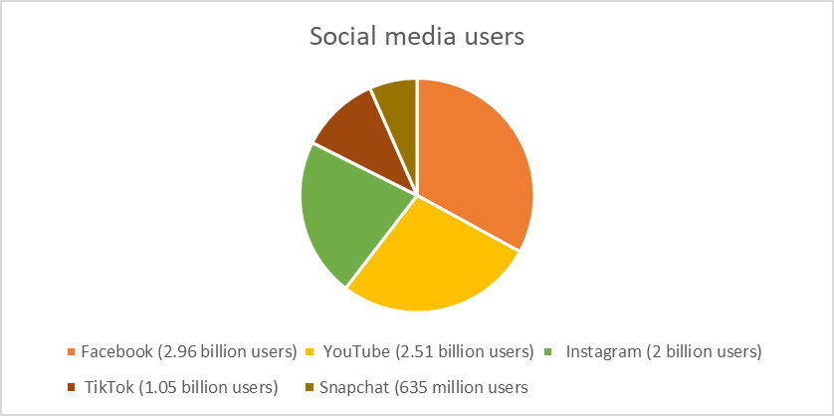

When using the above social media, some additional tools to promote an event and create posts:
- Canva ( https://www.canva.com/)
- Movavi Video Editor ( https://www.movavi.com/)
- Design Stripe (https://designstripe.com/)

Tips for pictures:
- Format: JPEG, TIFF
- Size: minimum 1800 x 2400 pixels
- Accompanying description: who/what is represented, when/where the picture was taken
- Credits: your project + any additional copyrights.
- Add Alt text describing your photos for visually impaired people.
- Use clear and high-quality photos.
Check out these videos to raise awareness of environmental issues:
LIFE DEBAG - Leave plastic bags in the past, not in our seas
IKEA – What if?
HP Sustainability | Parallel Lives | HP
Manufy: Fund the Future of Sustainable Fashion
Coke Sustainability TVC
Climate action starts at home - IKEA

Communication
The promotion should start with strategic planning to better organise the event or campaign and to better promote the green sport event.
Step 1: Determine the venue.
Step 2: Identify your target audience. [ Community engagement: students, neighbours, teachers, local authorities etc. Expert engagement: NGOs, research centres and private sector. Policy engagement: European institutions, international organisations, national policymakers etc. Media: Local papers, radio, websites, blog, TV channels.]
Step 3: Set SMART communication objectives (Specific, Measurable, Achievable, Relevant, Time-bound)
Step 4: Adapt the language to your messages for your target audience.
Step 5: Some key questions to know before the event are:
- Which stakeholders will participate or be affected by the event?
- Which of the stakeholders have responsibilities (delivery, etc.)?
- Which stakeholders can influence the public?
- What about an environmental plan? (How many greenhouse gas emissions will my event produce, what are the impacts and how will I ensure that wildlife is not disturbed?)
Based on the above answers, strategic and promotional planning can be developed, and sustainability can be shaped. Stakeholder involvement in the event is essential because the inclusion and collaboration of multiple partners can define a viable committee that will contribute to the event before, during and after. The inclusion of partners or stakeholders in the organisation of the event can increase engagement (NGOs, environmental agencies or local experts) and contribute to a greener sporting event through consultation and exchange of ideas.
In addition, working with stakeholders and NGOs can promote a more sustainable event and help monitor the environmental plan objectives set at the beginning of the event.
The promotion of the sports event can start with the online promotion of the event. Keeping the public and participants informed about what will take place during the event is a great opportunity to engage them.

Case Studies:
The following are some examples of how cooperation with organisations/people etc, can benefit and promote an event.
  - #WhoseSideAreYouOn: The campaign was launched in 2014 and aims to stop the illegal wildlife trade. Many well-known people are ambassadors, including Lewis Hamilton (Formula 1) and David Beckham (football).
  - Campaign for wildlife conservation: Lao People's Democratic Republic, NGOs, international organisations, companies and youth volunteers to spread the message of wildlife conservation to the thousands of visitors to the event. The event was covered by media such as TV, advertisements, radio, billboards and banners with the campaign slogan.
  - International mountain biking event: Absa Cape Epic is one of the world's largest off-road mountain bike races and is held annually in the landscapes of the Western Cape of South Africa. An environmental management plan is being prepared for the event that includes clear objectives and required performance outcomes. The plan includes levels of disturbance, damage to plant life and waste control. This event is monitored to minimise environmental damage. An Environmental Control Officer (ECO) monitors the site and ensures that no waste is left behind. A fire control officer also ensures that the event is safe in terms of fire risk and carries out daily checks on water intake points.

Before the event
Even before the event, raising awareness on environmental issues should be at the top of the agenda, so social media channels can be used to show the public why it is important/what they can do about it and what will happen during the event to raise awareness of the issues.
During the outreach it is also important to share ecological or environmental data with the public. This promotion can be done either on social media or in radio and TV broadcasts. Organisers can also present the entire event through social media. Transparency and sharing of information are important because the public can see the various ways that make an event greener. For example, venue preparation can be posted on social media and any recycling bins at the venue as behind-the-scenes stories.
In addition, the campaign to promote the event more broadly can have a hashtag and specific images/colours/message to make the event more attractive to the public.

During the event
Promotion during the event can give more visibility to the initiative. Live broadcasting or the possibility of an online audience can help to promote environmental issues. One of the biggest challenges during sporting events is the transport of the audience and participants and CO2 emissions. Consequently, some audiences who want to watch sport but not necessarily participate can do so via an online stream that also promotes a key aspect of climate change, which is to reduce unnecessary transport.
The promotion of environmental issues will take place throughout the event. For example, if the organisers are promoting a paperless or plastic-free policy during the event, then, prior to the event, they should promote the policy through the media and encourage participants to bring their own cups. In addition, if attendees selling products at the event will not have paper receipts but only digital receipts, organisers can inform attendees that they will receive them via email.
In addition, during the event, a person can have the role of social media manager to keep posting photos or stories. In addition, the social media manager may interview attendees or participants and create a video/reel or story for social media. It is important to have the consent of each person to be interviewed.
In addition, the public can bring their own materials to recycle, such as batteries or clothing, or host various workshops during the sporting event on how to reuse plastic bottles or old jeans.
All these environmental elements that will take place during the event should be promoted in advance so that the public is fully informed about all aspects of the event, but also to help create environmental thinking about how any actions can have an impact on the environment.

After the event
Promotion should continue after the end of the sporting event. Sharing videos or photos of participants afterwards can help promote the event. Also, another essential promotional activity is to inform the public about the event's impact on the environment. For example, using recycling bins during the event can also promote the event afterwards by showing people what happened to the recycled materials.

Education
As discussed in the previous chapter, through promotion a first encounter with environmental issues is made. However, in this chapter, promotion becomes a tool to promote the event and environmental education. Education is part of the promotion of the green event and is interrelated. One cannot exist without the other. Throughout the promotion of the event, education must be a priority.
First, education about what needs to be done. For example, explaining in advance what participants need to do or if they need training to perform a sport and, through training in a sport, develop any skills and build capacity.
In addition, environmental training should be achieved. The public should be aware of how their actions can affect the natural environment or ecosystem and how they can avoid impacts on these areas. Some of this information will be provided during the event and other information will be provided in advance or afterwards.

What can be included in the educational promotion of the green sports event?
Raise Awareness:
- Provide information to the sports teams about biodiversity on the venue and in the local area and how to protect it.
- Direct messages to fans and spectators about the ecosystem and wildlife at the venue. Share with participants what they should do to protect the ecosystem during the sporting event.
- Raise environmental awareness on various issues related to the sporting event. If the event will be related to waste collection, then the environmental awareness can be about waste or plastic management.
- Awareness raising for staff, volunteers or any other person involved about the biodiversity of the area.
- Contacting the environmental or forestry service (ecosystem or biodiversity of a particular area or venue) in the region or country can provide additional advice to share with the public prior to the event.
- Sports stars can be asked to share their ideas on environmental issues.
- Inform the public about local initiatives, environmental work or shops with environmentally friendly products.

Monitoring and reporting:
- Greenhouse gas emissions: Share with the public how many greenhouse gas emissions will be produced from transportation and operations before and after the event.
- What energy will be used during the event? (Green energy sources, temporary power generators, low-energy appliances and lighting).
- Venue: Details of the characteristics of the venue, any habitat or trees that are susceptible to erosion.
- Environmental risks of organising the event at the site/area.
- How the organisers will protect the ecosystem or any environmental features of the area.
- How pollution will be avoided.
- Share your knowledge and achievements - throughout the journey.

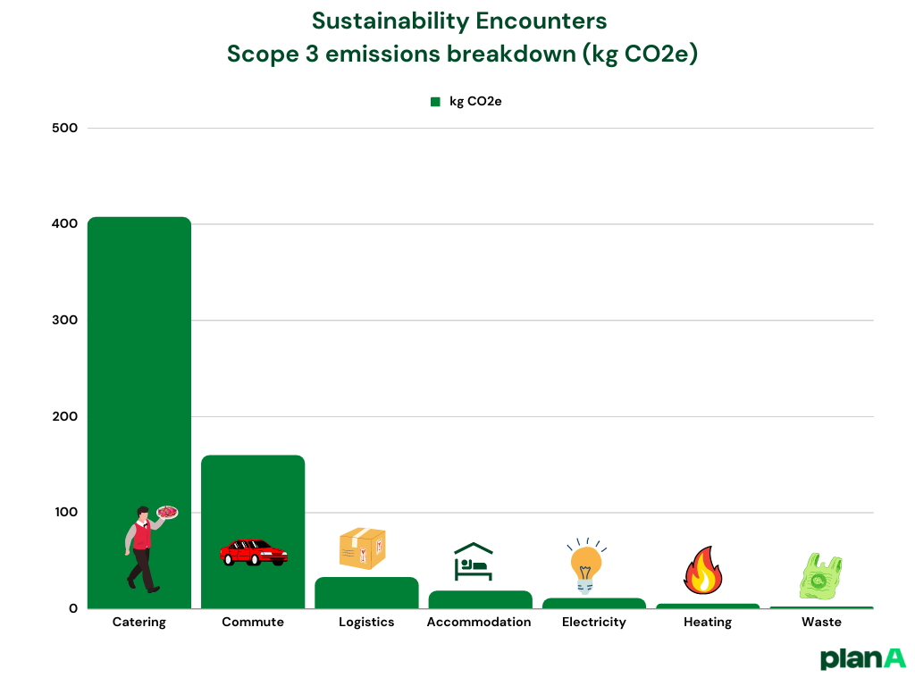
This website (https://plana.earth/product) helps event organisers to calculate their emissions. During the event, the organisers are asking each participant to fill in a survey via a QR code. They collect data on food, energy use etc.
Distribution of emissions of an event, Transparent sustainable events carbon emissions,

Advocacy
Advocacy can be described as an activity that aims to influence actions and decisions inside the political, social or economic system addressing a particular issue. It can be initiated by an individual, organisation or a group. This education and awareness raising activity is based on facts and can include media campaigns, publishing research, fundraising and public speaking.
When planning an advocacy process, it is necessary to start with a needs assessment in order to know who is responsible and has jurisdiction to make the decisions on the request you will be making. In addition, research into the legal regulations on local and state level of rules for advocacy. Scan for potential allies and if possible, build and strategically use that relationship.
The most important questions to have the clear answers to are: ‘’What do I want to achieve? ‘’ and ‘’How do I achieve this?’’ While answering these questions in detail, you will have a clear vision of activities and specific objectives that you need to complete to achieve your desired goal. Determine the level of your activity (local / National / International). Research what has already been done and possibly build on that.
There are two main target groups. The primary target group are the decision makers (e.g., ministries, prime minister, local / regional decision makers) as they are the ones that have the authority to accept and act upon your request.
The influencers (e.g., individuals and organisations, experts, researchers, media etc.) are the secondary target group as they can influence the primary target group. It is good to analyse what is their motivation, interests and what information do you need to provide them to join your pursuit.
The message you formulate has to be clear and structured as such that it leaves no space for misunderstandings as it will reflect your goal and its purpose. Aim to present the issue, share the story you want to be heard, engage the audience and connect their values and personal interests to your goal.
When choosing the channels of communication, have in mind the level of your advocacy activities (local, regional, international) and create a communication plan. List the stakeholders you want to reach and how you can reach them the best. For example, if you want to advocate on a local level, aim for local influencers, local NGO and CSOs, local media and events.
Raising funds for your action can be done through fundraising events, individual contributions, private or public foundation grants. The important aspect to remember is that your donors understand your goal and share the same values as you. Fundraising events can be in any form you want it to be as long as it fits your action, so be creative and consider the use of digital tools, organising auction or marathon, presentations on other public events, challenges, performances, flashmobs, etc. The donation needs to be easy and transparent. Pay a public tribute to your donors and aim to maintain good relations for further collaborations and good reference.
Tracking the advocacy process and the results of your plan is necessary to make sure you are consistent in your implementation and in line with your resources. Considering the constant change in the environment, your plan needs to be agile and you need to be prepared to implement adaptations. At the beginning of planning, think of all possible risks that can negatively influence your goal and think about ways to manage them to minimise it.

Now that you are acquainted with the basics of advocacy, we invite you to further explore the topic:

Further reading:
How to Create a Great Social Media Strategy Plan in 2023 and free Global Social Media Trends Report, https://blog.hubspot.com/marketing/social-media-strategy-for-your-business
How to plan a social media campaign, step by step, https://www.smartinsights.com/social-media-marketing/social-media-strategy/how-to-plan-a-social-media-marketing-campaign-step-by-step
A 10 Step Guide to a Successful Fundraising Event, https://thefundraisingauthority.com/fundraising-basics/fundraising-event
Three Best Practices for Sustaining Interest in Advocacy Efforts, https://www.asaecenter.org/resources/articles/an_plus/2022/03-march/three-best-practices-for-sustaining-interest-in-advocacy-efforts
Using Local Outreach to Engage the Online Generation, https://blog.techsoup.org/posts/using-local-outreach-to-engage-the-online-generation

Conclusion
In conclusion, creating a sustainable and green environment within the realm of sports is crucial for the well-being of our planet and future generations. While the transition may require effort and resources, the benefits extend beyond being environmentally friendly. By adopting sustainable practices, sports organisations can become leaders in the global green movement, attracting positive attention, fostering community engagement, and inspiring others to follow suit. The concept of a sustainable green sports environment is an opportunity to make a positive impact on local, national, and international levels, aligning with global goals and setting an example for others. It is a pathway towards a more responsible and inclusive future where sports and environmental stewardship go hand in hand.
The concept of a sustainable green sport environment is about integrating environmental responsibility into sports activities. By adopting sustainable practices, sport organisations can contribute to a healthier planet, inspire positive change, and reap financial and reputational benefits. The involvement model includes engaging at international, national, and local levels to drive mindset shifts, implement inclusive programs, collaborate with communities, and serve as role models for others.
The potential of sport lies in its ability to unite people, raise awareness, and create a lasting impact on the planet. Through collective action, we can harness the power of sports to build a more sustainable and greener future.

References
- https://education.nationalgeographic.org/resource/ecosystem/
- What is the media? | Macmillan Dictionary Blog, https://www.macmillandictionaryblog.com/media
- Brownlie, Susie, Bull, Joseph W. and Stubbs David (2020). Mitigating biodiversity impacts of sports events. Gland, Switzerland: IUCN. xiv+80 pp
- Digital 2023: Global Overview Report — DataReportal – Global Digital Insights, https://datareportal.com/reports/digital-2023-global-overview-report
- https://ilsocialepensa.altervista.org/la-comunita-locale/
- https://organizingengagement.org/models/ladder-of-childrens-participation/
- https://pathways.nice.org.uk/pathways/community-engagement
- https://www.aclimilano.it/le-comunita-locali-per-il-bene-comune-e-lo-sviluppo-sostenibile/
- https://www.coni.it/it/news/16058-siglato-protocollo-per-l-ambiente-lo-sport-italiano-diventa-plastic-free.html
- https://www.dors.it/documentazione/testo/201809/policybrief_def_20anni.pdf
- https://www.nytimes.com/2014/10/08/business/energy-environment/water-waste-going-going-.html?_r=0
- IOC Sustainability Strategy, 2017, http://extrassets.olympic.org/sustainability-strategy/
- IOCSports fro Climate Action, IOC, 2019, https://theuiaa.org/documents/sustainability/IOC-SPORTS-FOR-CLIMATE-ACTION.pdf
- Life Toolkit Communication tips booklet, https://ec.europa.eu/environment/archives/life/toolkit/comtools/documents/communication_tips_booklet.pdf
- Nacionalni program športa v republiki Sloveniji 2014-2020, https://www.ljubljana.si/assets/Uploads/nacionalni-program-sporta-RS-2014-2023.pdf
- NICE. Community engagement overview. NICE, 2017.
- Okoljevarstveni in naravovarstveni kodeks Olimpijskega komiteja Slovenije – Združenja športnih zvez, https://www.olympic.si/datoteke/Okoljevarstveni%20in%20naravovarstveni%20kodeks.pdf
- Olympic movement agenda 21, https://stillmed.olympic.org/media/Document%20Library/OlympicOrg/Documents/Olympism-in-Action/Environment/Olympic-Movement-s-Agenda-21.pdf
- Resolucija o nacionalnem programu varstva okolja za obdobje 2020–2030 (ReNPVO20-30), Državni zbor RS, 2020
- Sistem varstva narave v Sloveniji / [avtorji Mladen Berginc & Jelka Kremesec-Jevšenak & Jana Vidic]. – Ljubljana : Ministrstvo za okolje in prostor, 2007, https://www.gov.si/assets/ministrstva/MOP/Publikacije/a501ce9279/sistem_varstva.pdf
- Social Media: Definition, Effects, and List of Top Apps (investopedia.com), https://www.investopedia.com/terms/s/social-media.asp
- Sports for Climate Action Framework, United Nations, https://unfccc.int/sites/default/files/resource/Sports_for_Climate_Action_Declaration_and_Framework.pdf
- Sports for Climate Action, UN, https://unfccc.int/climate-action/sectoral-engagement/sports-for-climate-action
- What is the media? | Macmillan Dictionary Blog, https://www.macmillandictionaryblog.com/media
- Social Media: Definition, Effects, and List of Top Apps (investopedia.com), https://www.investopedia.com/terms/s/social-media.asp
- Digital 2023: Global Overview Report — DataReportal – Global Digital Insights, https://datareportal.com/reports/digital-2023-global-overview-report
- Life Toolkit Communication tips booklet, https://ec.europa.eu/environment/archives/life/toolkit/comtools/documents/communication_tips_booklet.pdf
- Sports for Climate Action, UN, https://unfccc.int/climate-action/sectoral-engagement/sports-for-climate-action
- Sports for Climate Action Framework, United Nations, https://unfccc.int/sites/default/files/resource/Sports_for_Climate_Action_Declaration_and_Framework.pdf
- Olympic movement agenda 21, https://stillmed.olympic.org/media/Document%20Library/OlympicOrg/Documents/Olympism-in-Action/Environment/Olympic-Movement-s-Agenda-21.pdf
- IOC Sustainability Strategy, 2017, http://extrassets.olympic.org/sustainability-strategy/
- IOCSports for Climate Action, IOC, 2019, https://theuiaa.org/documents/sustainability/IOC-SPORTS-FOR-CLIMATE-ACTION.pdf
- NICE. Community engagement overview. NICE, 2017.
- https://pathways.nice.org.uk/pathways/community-engagement
- https://organizingengagement.org/models/ladder-of-childrens-participation/
- https://www.dors.it/documentazione/testo/201809/policybrief_def_20anni.pdf
- https://ilsocialepensa.altervista.org/la-comunita-locale/
- https://www.aclimilano.it/le-comunita-locali-per-il-bene-comune-e-lo-sviluppo-sostenibile/

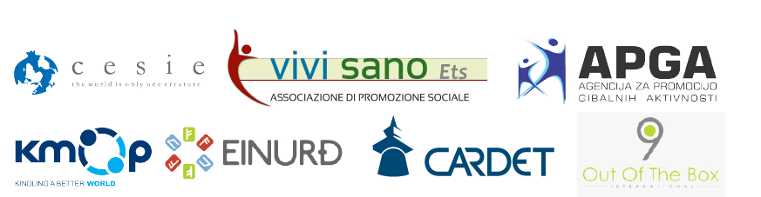

https://education.nationalgeographic.org/resource/ecosystem/
For further information, see the training package section on Ecosystems
Brownlie, Susie, Bull, Joseph W. and Stubbs David (2020). Mitigating biodiversity impacts of sports events. Gland, Switzerland: IUCN. xiv+80 pp
Source: Resolution Of the Council and of the Representatives of the Governments of the Member States meeting within the Council on the European Union Work Plan for Sport https://eur-lex.europa.eu/legal-content/EN/TXT/?uri=CELEX:42020Y1204(01) Last visited: 07.06.2023.
Source: COMMISSION OF THE EUROPEAN COMMUNITIES; https://eur-lex.europa.eu/legal-content/EN/TXT/HTML/?uri=CELEX:52007SC0935&from=FR Last visited: 07.06.2023.
https://www.un.org/youthenvoy/environment-climate-change/
https://www.sailsofchange.org/sports-and-nature-on-the-same-team/#:~:text=Sports%20and%20nature%20are%20intrinsically,our%20desire%20to%20protect%20it
https://www.un.org/development/desa/dspd/2022/02/addressing-climate-change-through-sport/#:~:text=In%20a%20cyclical%20manner%2C%20the,having%20disruptive%20consequences%20on%20sport
https://www.fgr.co.uk/another-way
https://www.reviewjournal.com/news/politics-and-government/clark-county/new-golf-courses-cant-use-colorado-river-water-las-vegas-board-says-2470511/
Sports for Climate Action, UN, https://unfccc.int/climate-action/sectoral-engagement/sports-for-climate-action
What is the media? | Macmillan Dictionary Blog
Social Media: Definition, Effects, and List of Top Apps (investopedia.com)
Digital 2023: Global Overview Report — DataReportal – Global Digital Insights
Life Toolkit Communication tips booklet

